Git Operations Execution Report
BITS Pilani — DevOps (CSI ZG514) | Lab Sheet 1
Case 2: PMO-Office Project
Central repository, inventory Excel, commit, and push

1. Introduction
As a PMO member, planning and inventory files are maintained in a central GitHub repository. An Excel inventory sheet is added and updated; additional files are committed locally and pushed to the server.

2. Execution Summary
Project folder | Lab Assignment\PMO-Office
GitHub repository | https://github.com/2025tm93239/PMO-Office
Inventory file | PMO-Office\Inventory.xlsx
Branch | main
Local workflow | clone/init → edit files → git add → git commit → git push
Evidence folder | PMO-Office\Screenshots (also on GitHub)

3. Key Commands Used
git init | git add Inventory.xlsx README.md
git commit -m "message" | git remote add origin <url>
git push -u origin main | git pull origin main

4. Screenshots (Git Operations Evidence)
All PMO-Office Git operation screenshots are included below with brief descriptions.
Screenshot 1: GitHub account / new PMO-Office repository created.
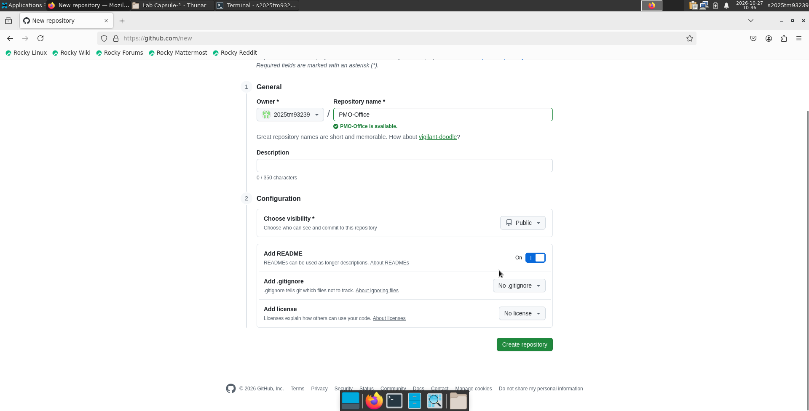

Screenshot 2: Repository settings or initial empty project on GitHub.
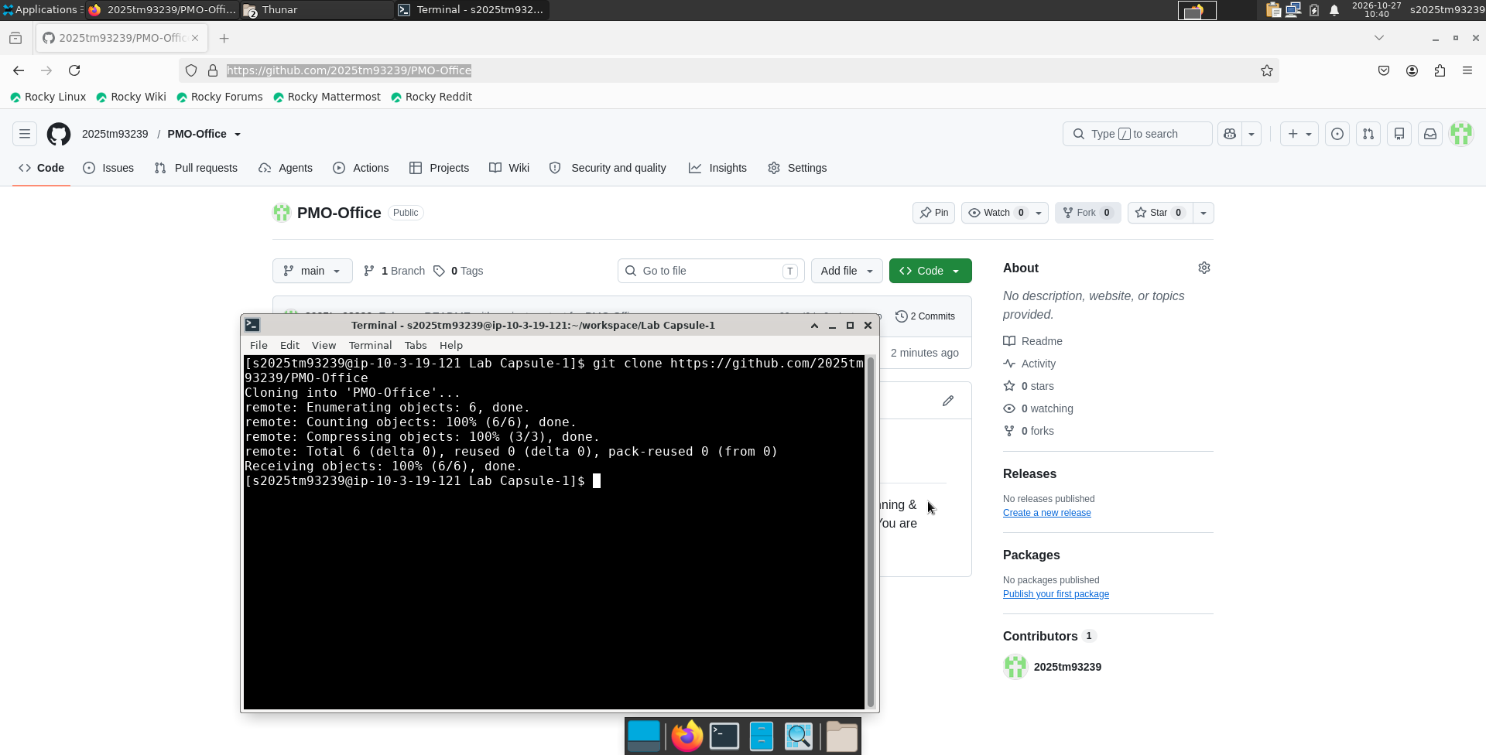

Screenshot 3: Create or add Inventory.xlsx locally.
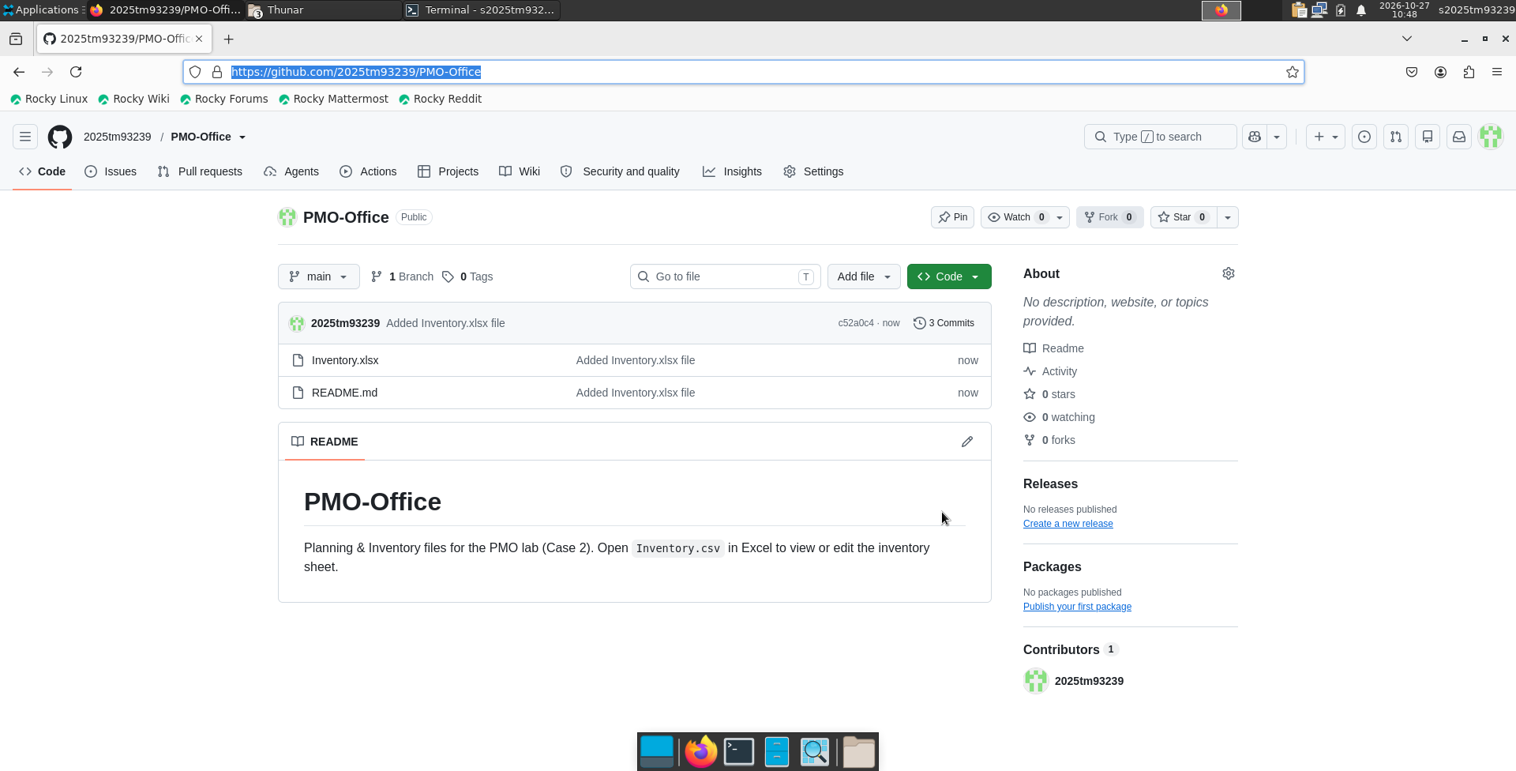

Screenshot 4: git status — files ready to stage.
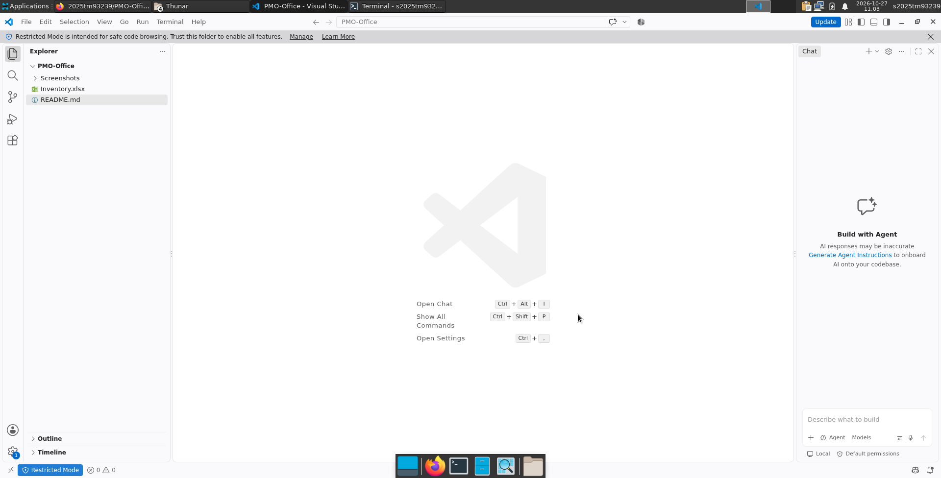

Screenshot 5: git add — staging inventory and README.
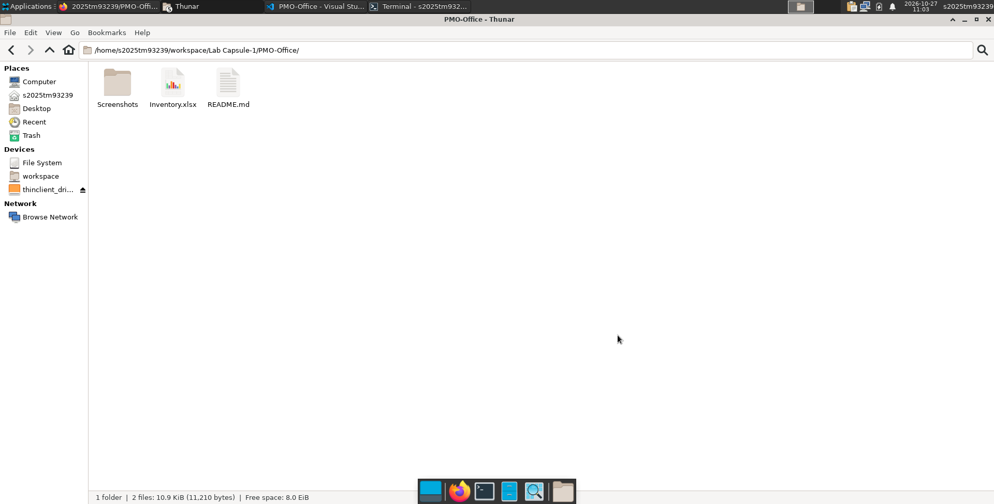

Screenshot 6: git commit — saving changes to local repository.
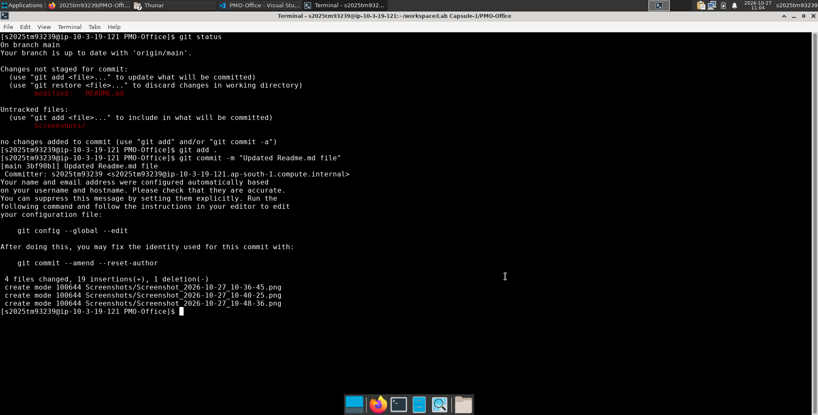

Screenshot 7: git remote / linking local repo to GitHub.
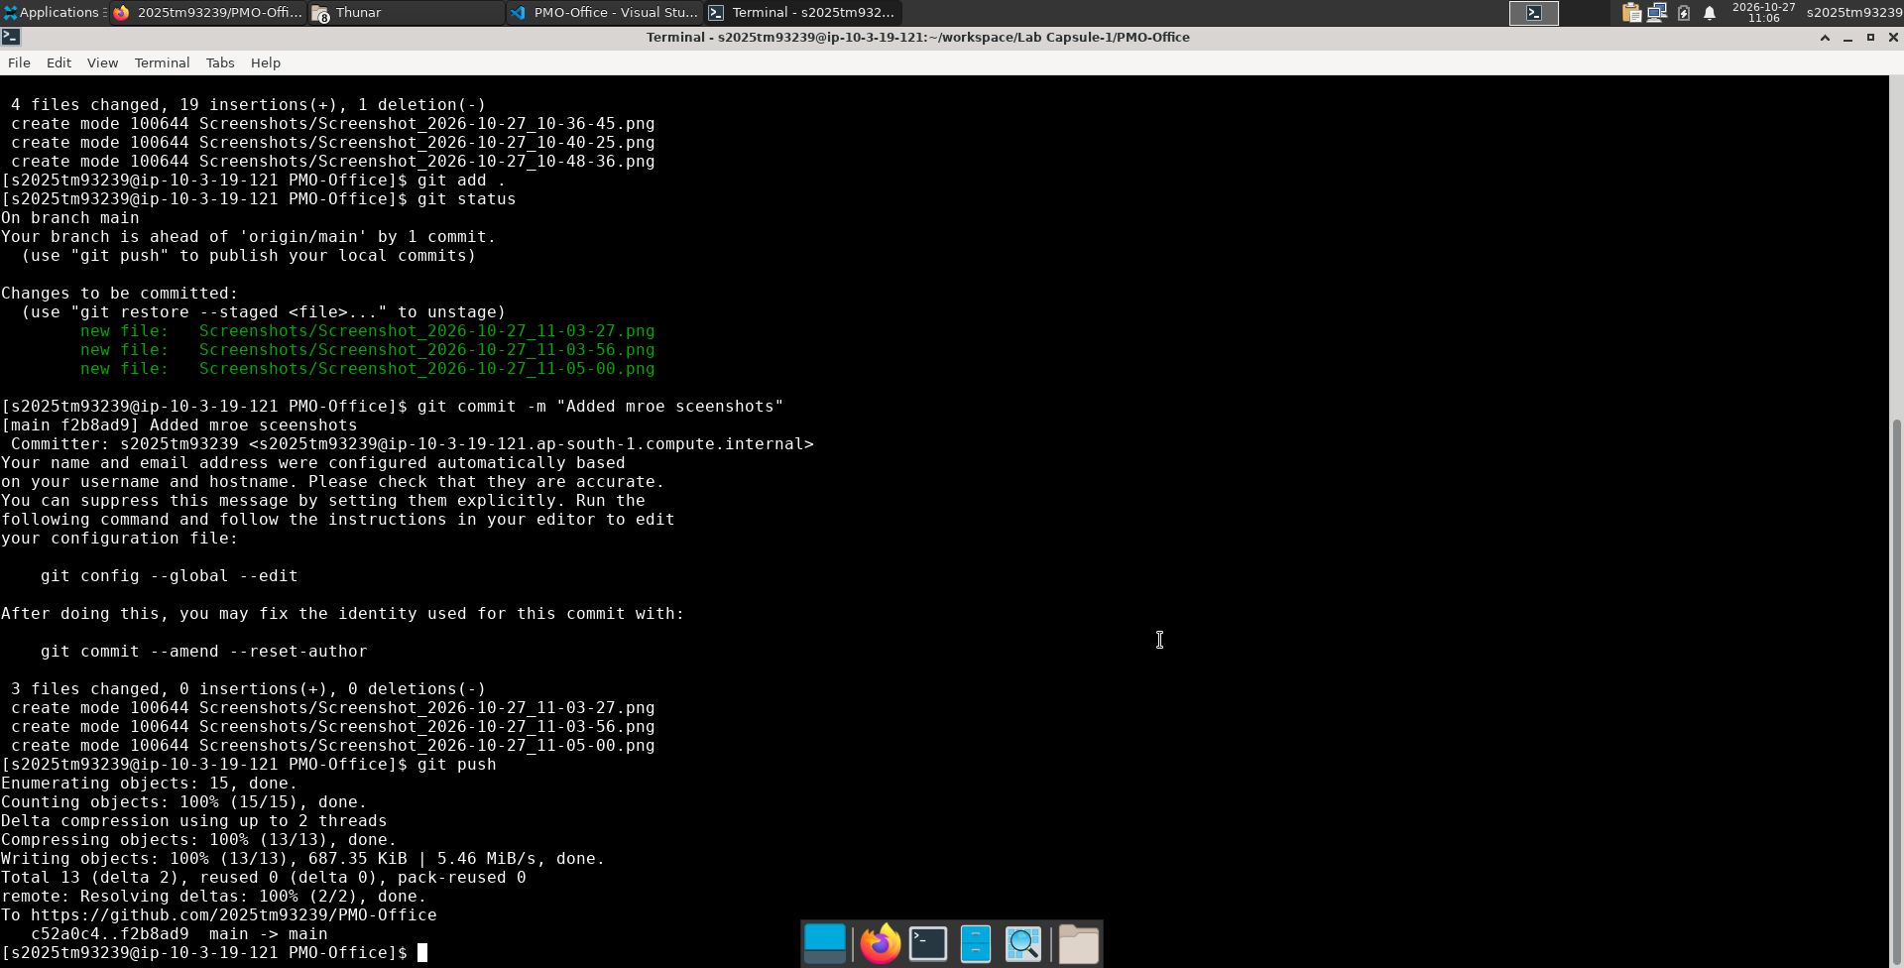

Screenshot 8: git push — uploading commits to central server.
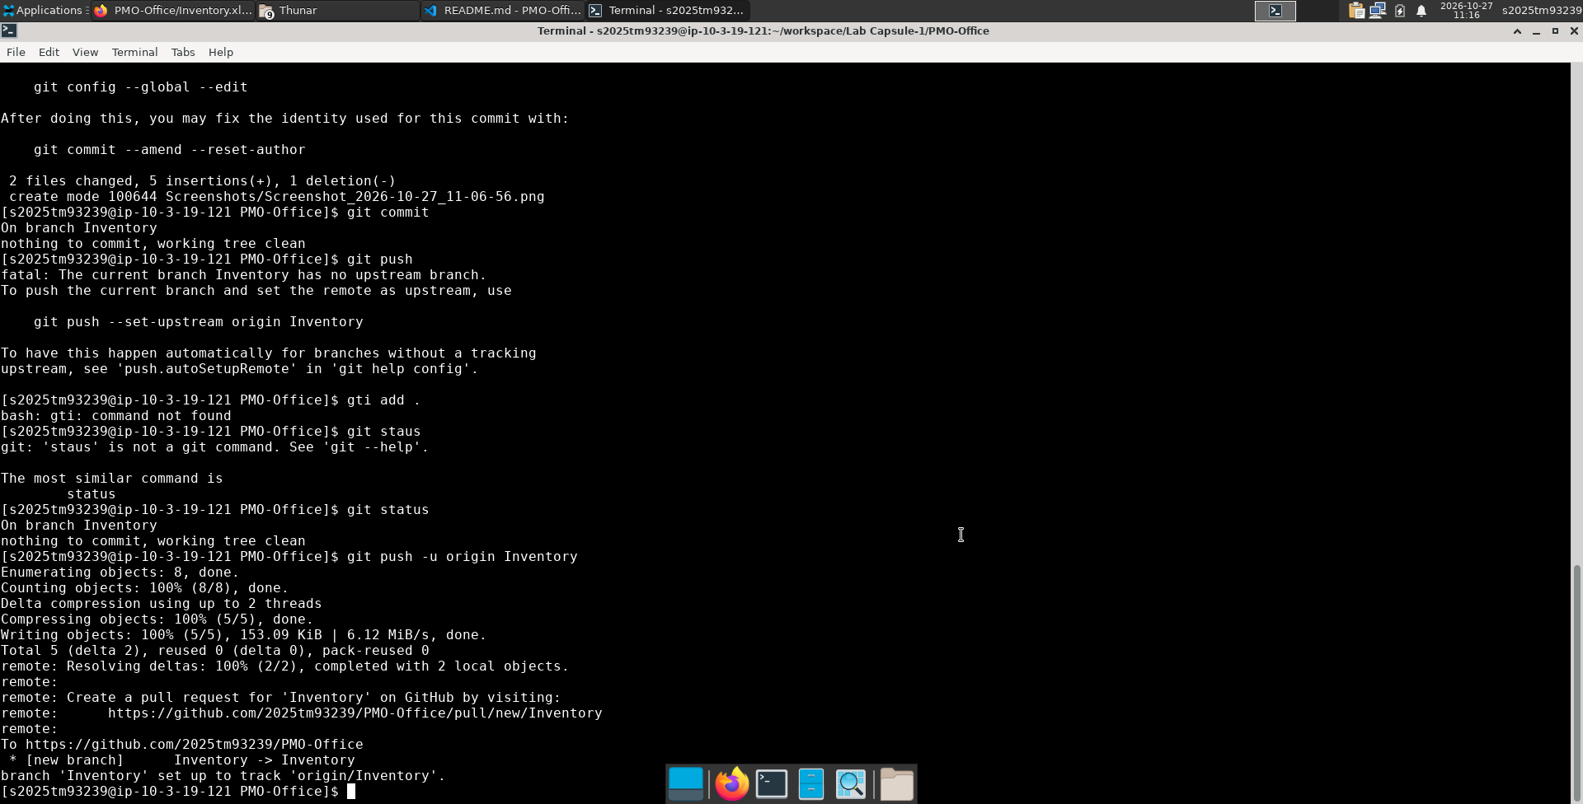

Screenshot 9: GitHub view — Inventory.xlsx on remote repository.
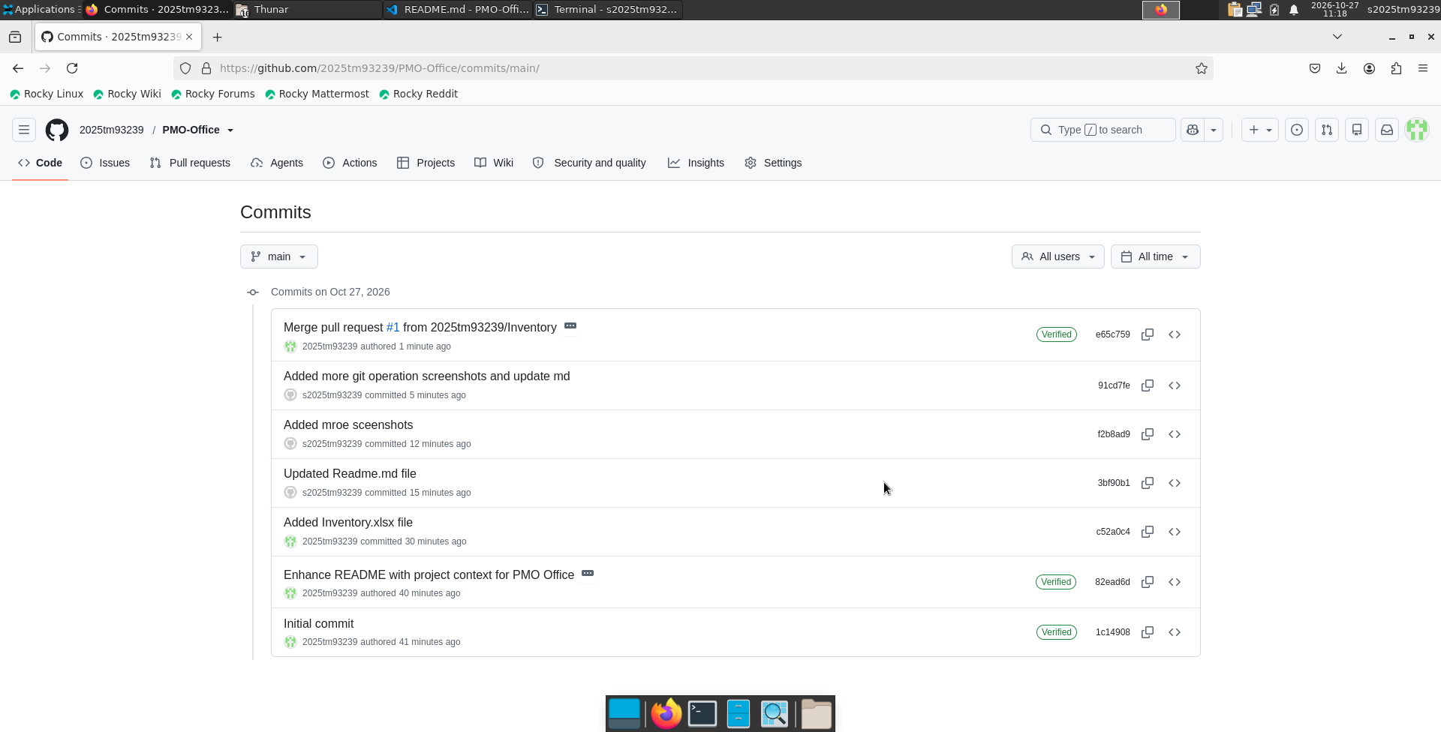

Screenshot 10: Append/update inventory or add new PMO files.
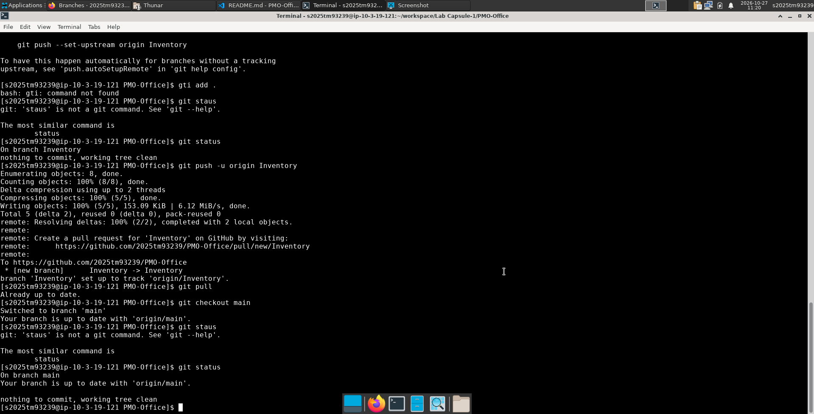

Screenshot 11: git log — commit history on main branch.
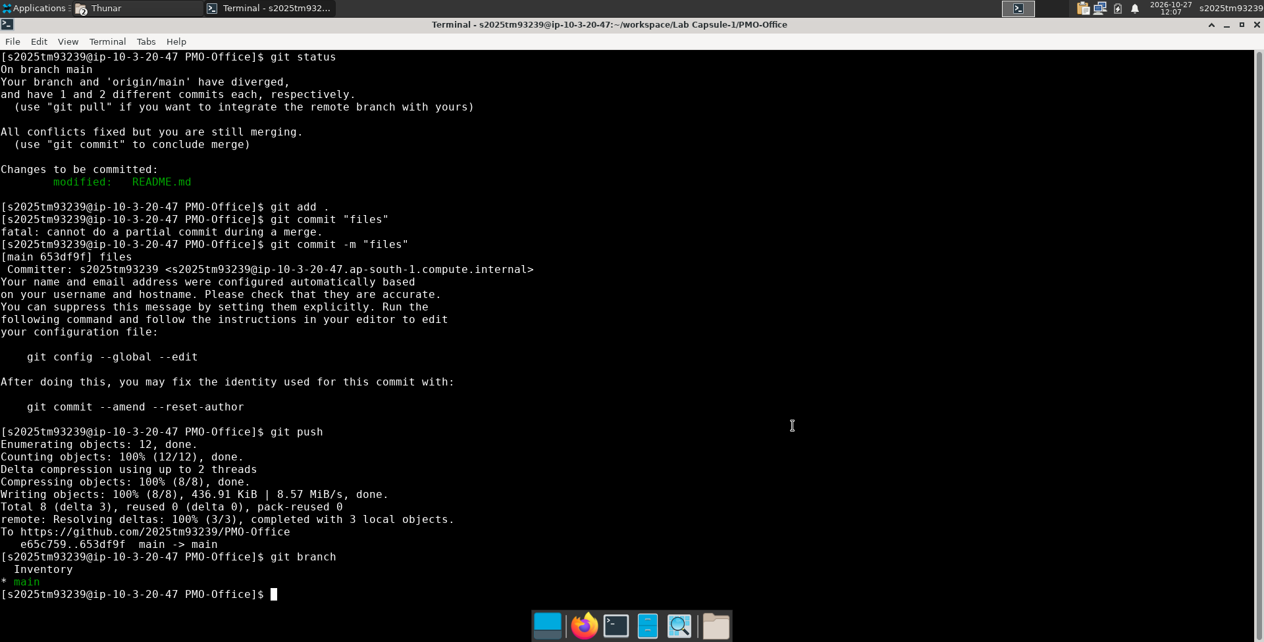

5. Observations
The PMO-Office repo centralizes inventory and planning artifacts. Each commit records who changed what and when; push publishes updates for all locations.

